**Assignment 2: Traffic analysis and risk register**

**Project Scope**

The project’s main goal is to create a traffic analyser that would help determine the number of pedestrian traffic. The project’s main vision is

**To create a safe environment for pedestrians by analysing traffic and developing solutions.**

The project uses a motion sensor that detects whenever an individual passes through series of sequence patterns. The main functionality of this project is to be able to keep track of the number of individuals given that they pass by the sensor and upload the data in realtime to the client side (in this case, the browser page).

The project would use a motion sensor that identifies whether a person has passed through or not. The app recognises whether the pattern given from the motion sensor matches the pattern of an individual.

If the motion sensor gives the following pattern:

**Long Short Long Long**

Then the pattern should recognise an individual and blink the LED for 15 seconds. If the 15 seconds are not over and a new individual is passing through then the LED should blink for an extra 5 seconds.

The number of individuals passing is saved to the Firebase and in turn, the number of pedestrians is updated into the client side.

**Overview diagram:**

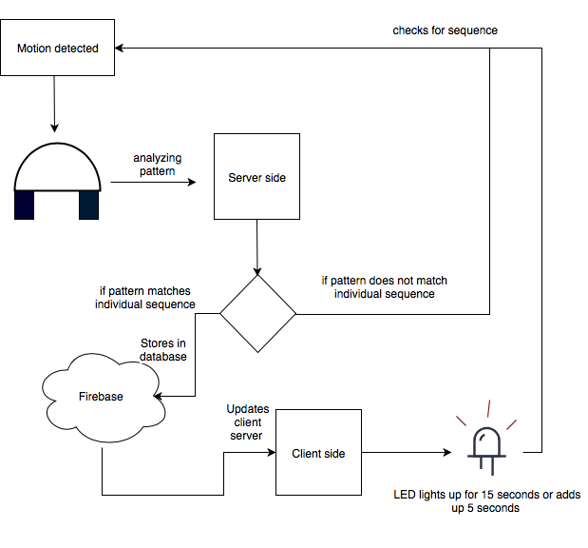

**Background of tools:**

There are a number of tools used to make this project possible. The main tools used are mentioned below with descriptions on their functionalities.

**Node.js:**

It is a free open source server framework that uses Javascript. Node.js can help with editing files on the server, collect form data and edit data on a database used in the web application. Node.js also provides libraries in javascript to ease web developing processes.

**Socket.io:**

It is a tool that is used mainly for web developing. It helps with communication between the client and the server. Whenever the client requests anything using the browser, the request is sent to the server side through socket.io. In that sense, socket.io helps give real-time feedback to the client in a web application.

**Firebase:**

It is a service that helps build application infrastructure. It provides functionalities such as analytics, databases, messaging and crash reporting. Firebase stores the application’s database on the cloud and updates automatically from the client’s side. It also uses authentication to protect the data stored in the cloud. For this project, Firebase is used to collect the data from the server and update it into the database which in turn would be updated to the client side.

**Key attributes of solution:**

**Motion sensor:**

If the motion sensor is configured correctly and plugged into the right ports on the beaglebone black, the motion sensor is believed to be able to detect motion accurately.

**Firebase:**

The firebase stores data on the cloud, so it helps saves costs on storage. It can also prevent data loss in contrary to if the data is saved on localised storage.

**Beaglebone black:**

Since the project relies on real time functionalities and is linux based. The beaglebone black is suitable for this project.

**Key constraints of solution:**

**Motion sensor:**

The motion sensor used is a vital part of this project. However, there are many issues produced when using it. The motion sensor can sometimes output that a motion has been detected when there isn’t any motion provided (False positive) or it can result in a motion not detected output when there is motion produced (False negative).

**Firebase:**

Firebase is one of the tools used. It provides the database for this project. however , an issue that needs to be considered is how it needs a stable internet connection to work well. Therefore, any instability in the internet connection might lead to loss of data from the server. In a much larger scale, firebase would need additional costs to store all the data collected.

**LED:**

Leaving the LED light on the ports of the beaglebone black for too long might cause a burnout in the LED. For this project, the LED is used to indicate that a person has passed through the motion sensor by blinking. If this project is used in a much larger setting, the LED light would have to be replaced very often.

**Beaglebone black:**

The beaglebone black is the processor used for this project. The beaglebone would sometimes disconnect and would often need reconfiguration. The motion sensor and the LED won’t be able to function if the beaglebone is not connected. The beaglebone has also proved to be slow at times.

***References***

**Risk Register**

Watterston, C., Matica, & Eva, T. (2018). Top Ten Major Risks Associated With Cloud Storage. Cloudwards. Retrieved 8 April 2018, from <https://www.cloudwards.net/top-ten-major-risks-associated-with-cloud-storage/>

Week 2 Slide Set, FIT3140: Advanced Programming, Sem 1 (2018).